The DownpourSGD architecture is a data-parallel setup, meaning each worker has the entire model and is operating on data different from the other workers (data-parallel), as opposed to having different parts of the model on different machines (model-parallel).

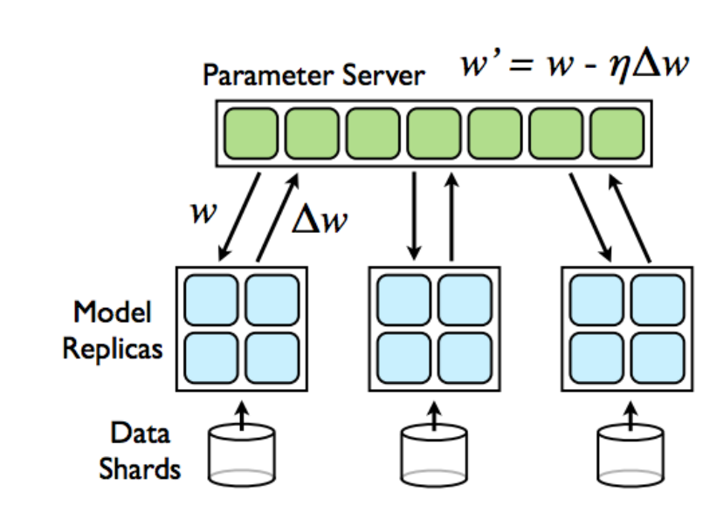
Data Parallelism

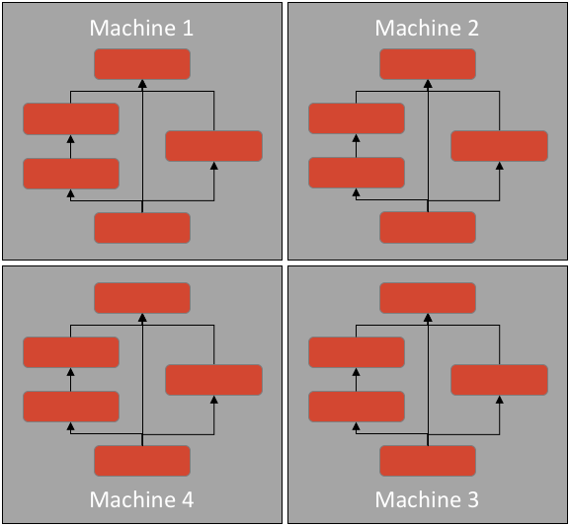
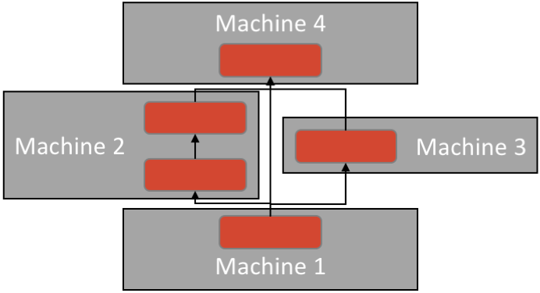
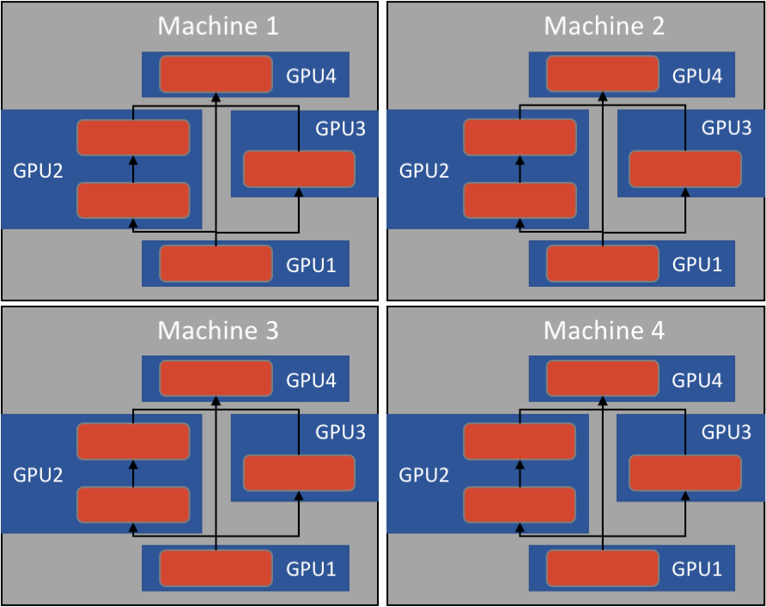

Data parallelism Model Parallelism Model + data

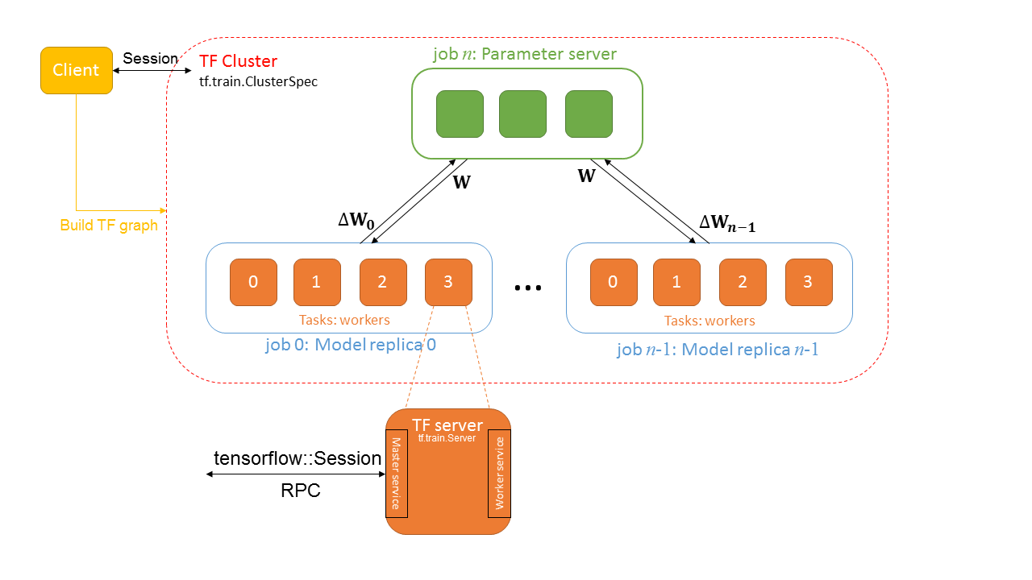

In the figure, the model parallelism within every model replica and data parallelism among replicas are adopted, for distributed deep learning. A example of mapping physical nodes to TensorFlow glossary is illustrated.
- The whole system is mapped to a TF cluster.
- Parameter servers are mapped to a job
- Each model replica is mapped to a job
- Each physical computing node is mapped to a task within its job
- Each task has a TF server, using “Master service” to communicate and coordinate works and using “Worker service” to compute designated operations in the TF graph by local devices.

Taken from TF official doc we have “

Client
A client is typically a program that builds a TensorFlow graph and constructs a `tensorflow::Session` to interact with a cluster. Clients are typically written in Python or C++. A single client process can directly interact with multiple TensorFlow servers (see “Replicated training” above), and a single server can serve multiple clients.
Cluster
A TensorFlow cluster comprises a one or more “jobs”, each divided into lists of one or more “tasks”. A cluster is typically dedicated to a particular high-level objective, such as training a neural network, using many machines in parallel. A cluster is defined by a `tf.train.ClusterSpec` object.
Job
A job comprises a list of “tasks”, which typically serve a common purpose. For example, a job named `ps` (for “parameter server”) typically hosts nodes that store and update variables; while a job named `worker` typically hosts stateless nodes that perform compute-intensive tasks. The tasks in a job typically run on different machines. The set of job roles is flexible: for example, a `worker` may maintain some state.
Master service
An RPC service that provides remote access to a set of distributed devices, and acts as a session target. The master service implements the tensorflow::Session interface, and is responsible for coordinating work across one or more “worker services”. All TensorFlow servers implement the master service.
Task
A task corresponds to a specific TensorFlow server, and typically corresponds to a single process. A task belongs to a particular “job” and is identified by its index within that job’s list of tasks.
TensorFlow server
A process running a tf.train.Server instance, which is a member of a cluster, and exports a “master service” and “worker service”.
Worker service
An RPC service that executes parts of a TensorFlow graph using its local devices. A worker service implementsworker_service.proto. All TensorFlow servers implement the worker service.

Replicated training
A common training configuration, called "data parallelism," involves multiple tasks in a worker job training the same model on different mini-batches of data, updating shared parameters hosted in one or more tasks in a ps job. All tasks typically run on different machines. There are many ways to specify this structure in TensorFlow, and we are building libraries that will simplify the work of specifying a replicated model. Possible approaches include:
- In-graph replication. In this approach, the client builds a single tf.Graph that contains one set of parameters (in tf.Variable nodes pinned to /job:ps); and multiple copies of the compute-intensive part of the model, each pinned to a different task in /job:worker.
- Between-graph replication. In this approach, there is a separate client for each /job:worker task, typically in the same process as the worker task. Each client builds a similar graph containing the parameters (pinned to /job:ps as before using tf.train.replica_device_setter to map them deterministically to the same tasks); and a single copy of the compute-intensive part of the model, pinned to the local task in /job:worker.
- Asynchronous training. In this approach, each replica of the graph has an independent training loop that executes without coordination. It is compatible with both forms of replication above.
- Synchronous training. In this approach, all of the replicas read the same values for the current parameters, compute gradients in parallel, and then apply them together. It is compatible with in-graph replication (e.g. using gradient averaging as in the CIFAR-10 multi-GPU trainer), and between-graph replication (e.g. using the tf.train.SyncReplicasOptimizer).

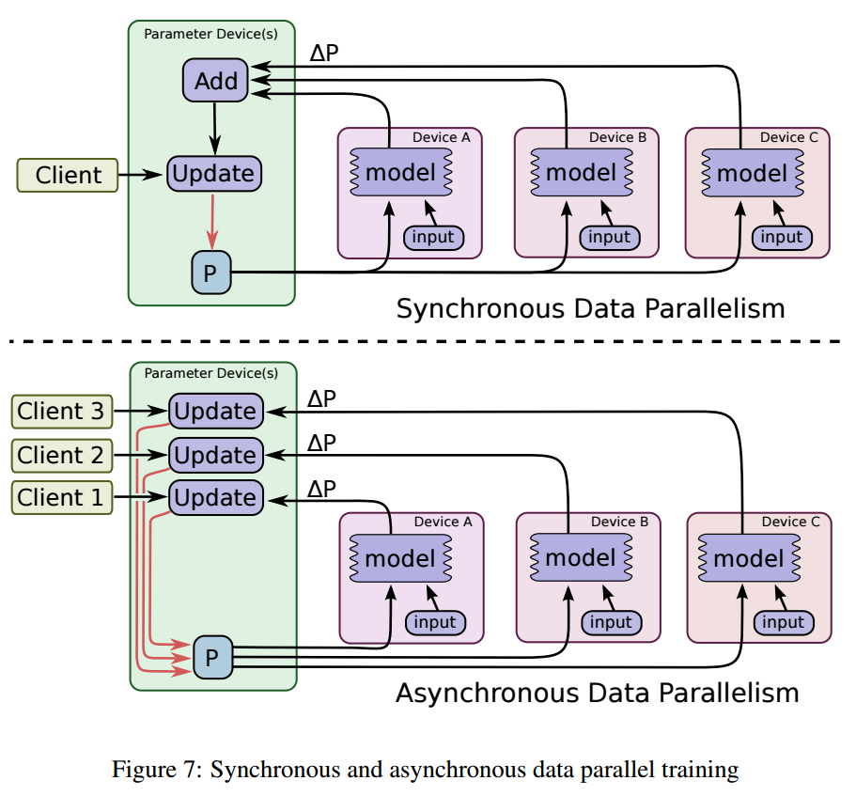

The server.join() method simply tells TensorFlow to block and listen for requests until the server shuts down (which currently means it blocks forever, or until you kill the process, since clean shutdown isn't currently implemented).
The with tf.device(tf.train.replica_device_setter(...)): block tells TensorFlow to put each variable on a different PS task by setting its device to "/job:ps/task:{i}" (for different values of {i}, chosen in a round-robin fashion).

See these once :
https://stackoverflow.com/questions/40216948/what-is-the-right-way-to-do-model-parallelism-in-tensorflow

https://clindatsci.com/blog/2017/5/31/distributed-tensorflow
https://www.tensorflow.org/performance/performance_models
https://www.tensorflow.org/extend/architecture#code
https://www.youtube.com/watch?v=la_M6bCV91M&t=46

